**3.24**

#include <iostream>

using namespace std;

int main()

{

// Prompt the user to enter an integer

cout << "Enter an integer: ";

int x;

cin >> x;

// Is integer divisible by 5 and 6?

if ((x % 5 == 0) && (x % 6 == 0))

cout << "Is " << x << " divisible by 5 and 6? true" << endl;

else

cout << "Is " << x << " divisible by 5 and 6? false" << endl;

// Is integer divisible by 5 or 6?

if ((x % 5 == 0) || (x % 6 == 0))

cout << "Is " << x << " divisible by 5 or 6? true" << endl;

else

cout << "Is " << x << " divisible by 5 or 6? false" << endl;

// Is integer divisible by 5 or 6, but not both?

if (((x % 5 == 0) || (x % 6 == 0)) && !((x % 5 == 0) && (x % 6 == 0)))

cout << "Is " << x << " divisible by 5 or 6, but not both? true" << endl;

else

cout << "Is " << x << " divisible by 5 or 6, but not both? false" << endl;

system("pause");

return 0;

}

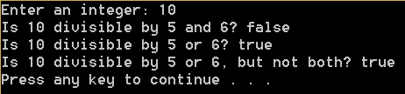

**3.35**

#include <iostream>

using namespace std;

int main()

{

// Prompt the user to enter 9 digits

int number;

cout << "Enter the first 9 digits of an ISBN as integer: " << endl;

cin >> number;

// Separate each digit

int d1, d2, d3, d4, d5, d6, d7, d8, d9, remaining;

d1 = number / 100000000;

remaining = number % 100000000;

d2 = remaining / 10000000;

remaining = remaining % 10000000;

d3 = remaining / 1000000;

remaining = remaining % 1000000;

d4 = remaining / 100000;

remaining = remaining % 100000;

d5 = remaining / 10000;

remaining = remaining % 10000;

d6 = remaining / 1000;

remaining = remaining % 1000;

d7 = remaining / 100;

remaining = remaining % 100;

d8 = remaining / 10;

remaining = remaining % 10;

d9 = remaining;

// Calculate d10

int d10;

d10 = ((d1 * 1) + (d2 * 2) + (d3 * 3) + (d4 * 4) + (d5 * 5) +

(d6 * 6) + (d7 * 7) + (d8 * 8) + (d9 * 9)) % 11;

// Display the ISBN-10 number with the conditions

if (d10 == 10)

cout << "The ISBN-10 number is "

<< d1 << d2 << d3 << d4 << d5 << d6 << d7 << d8 << d9 << "X\n";

else

cout << "The ISBN-10 number is "

<< d1 << d2 << d3 << d4 << d5 << d6 << d7 << d8 << d9 << d10 << endl;

system("pause");

return 0;

}

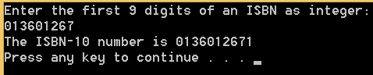

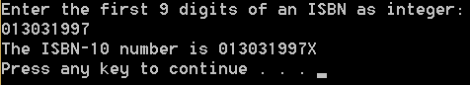

**3.36**

#include <iostream>

using namespace std;

int main()

{

// Prompt the user to enter a 3-digit number

int number;

cout << "Enter a three-digit integer: \n";

cin >> number;

// Separate each digit

int d1, d3;

d1 = number / 100;

d3 = number % 10;

// Check whether the number is palindrome

if (d1 == d3)

cout << number << " is a palindrome\n";

else

cout << number << " is not a palindrome\n";

system("pause");

return 0;

}

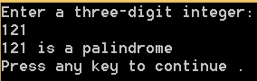 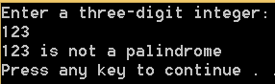

**4.5**

#include <iostream>

#include <iomanip>

using namespace std;

int main()

{

// Prompt user to enter number of sides and side length

int n;

double s;

cout << "Enter the number of sides: \n";

cin >> n;

cout << "Enter the length of a side: \n";

cin >> s;

// Calculate the area and display results

const double PI = 3.14159;

double area;

area = (n * (pow(s, 2))) / (4 * tan(PI / n));

cout << "The area of the polygon is " << fixed << setprecision(2) << area << endl;

system("pause");

return 0;

}

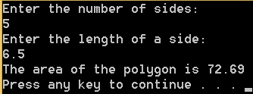

**4.17**

#include <iostream>

#include <string>

using namespace std;

int main()

{

// Prompt the user to enter 9 digits

string number;

cout << "Enter the first 9 digits of an ISBN as integer: \n";

getline(cin, number);

// Separate each digit

int d1, d2, d3, d4, d5, d6, d7, d8, d9;

d1 = number[0] - 48;

d2 = number[1] - 48;

d3 = number[2] - 48;

d4 = number[3] - 48;

d5 = number[4] - 48;

d6 = number[5] - 48;

d7 = number[6] - 48;

d8 = number[7] - 48;

d9 = number[8] - 48;

// Calculate d10

int d10;

d10 = ((d1 * 1) + (d2 * 2) + (d3 * 3) + (d4 * 4) + (d5 * 5) +

(d6 * 6) + (d7 * 7) + (d8 * 8) + (d9 * 9)) % 11;

// Display the ISBN-10 number with the conditions

if (d10 == 10)

cout << "The ISBN-10 number is "

<< number << "X\n";

else

cout << "The ISBN-10 number is "

<< number << d10 << endl;

system("pause");

return 0;

}

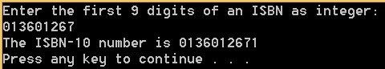

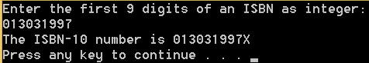

**4.21**

#include <iostream>

using namespace std;

int main()

{

char major, status;

cout << "Enter two characters \n" <<

"(first character would be your major - M for Mathematics\n" <<

"- C for Computer Science - I for Information Technology \n" <<

"and second character would be your status\n" <<

"- 1 for Freshman - 2 for Sophomore - 3 for Junior - 4 for Senior\n";

cin >> major >> status;

major = toupper(major);

switch (major)

{

case 'M':

if (status == '1')

cout << "Mathematics Freshman\n";

else if (status == '2')

cout << "Mathematics Sophomore\n";

else if (status == '3')

cout << "Mathematics Junior\n";

else if (status == '4')

cout << "Mathematics Senior\n";

else

cout << "Invalid status\n";

break;

case 'C':

if (status == '1')

cout << "Computer Science Freshman\n";

else if (status == '2')

cout << "Computer Science Sophomore\n";

else if (status == '3')

cout << "Computer Science Junior\n";

else if (status == '4')

cout << "Computer Science Senior\n";

else

cout << "Invalid status\n";

break;

case 'I':

if (status == '1')

cout << "Information Technology Freshman\n";

else if (status == '2')

cout << "Information Technology Sophomore\n";

else if (status == '3')

cout << "Information Technology Junior\n";

else if (status == '4')

cout << "Information Technology Senior\n";

else

cout << "Invalid status\n";

break;

default: cout << "Invalid Major\n";

}

system("pause");

return 0;

}

